Enrolling a Device in Intune
1. Enter the address of the Microsoft Intune portal into your web browser.
2. Click the Enroll button (see Figure 6.11).
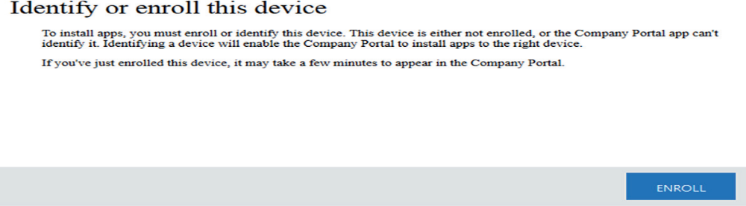
3. On the Enroll Your Computer screen, click the Download Software button (see Figure 6.12).
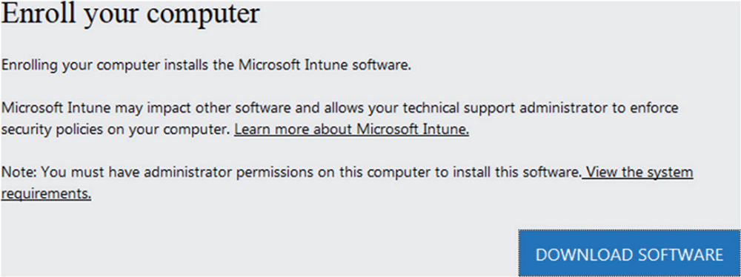
4. If the Save As box appears, click the Save File button (see Figure 6.13). If the download
automatically starts, go to step 5.
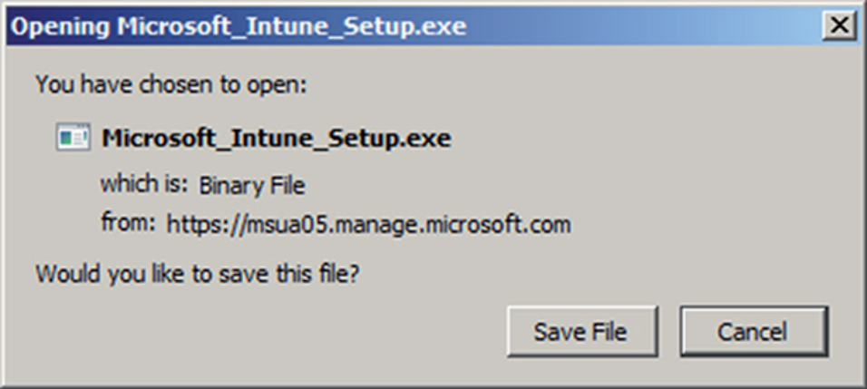
5. Once the file is downloaded, click the Run button.
6. The Microsoft Intune login screen will appear, as shown in Figure 6.14. Log into Microsoft Intune.
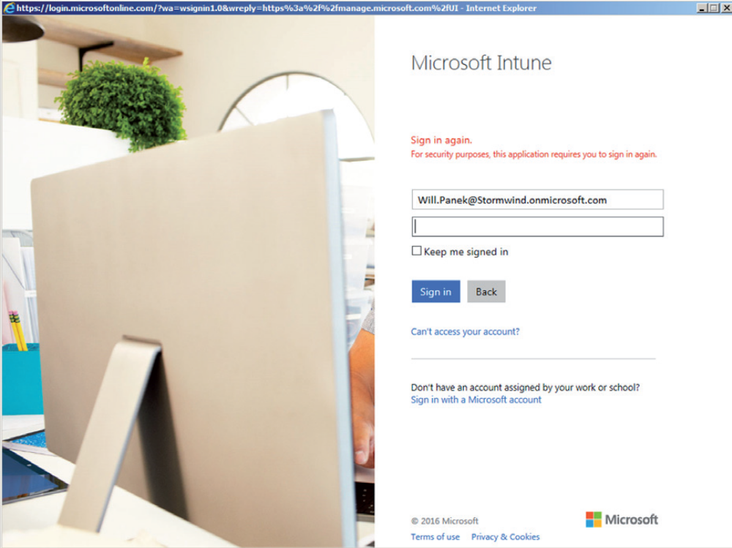
7. On the Welcome To Microsoft Intune Setup Wizard screen, click Next (see Figure 6.15).
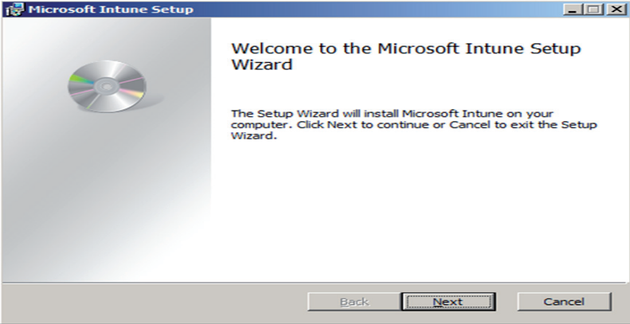
8. Microsoft Intune will be installed. If a User Account Control box appears, click Yes.
9. On the Complete screen, click the Finish button.
10. Log back into the Microsoft Intune portal.
11. If the message states that the computer is still not recognized, click the message. A box will appear, asking if you now want your computer to be enrolled. Click the radio button next to your system name and click the Select button, as shown in Figure 6.16.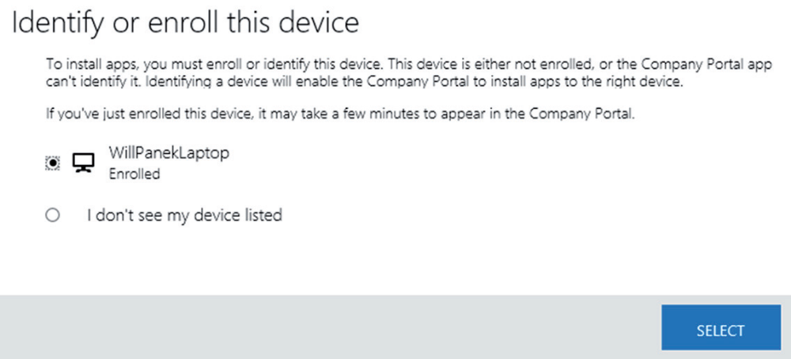
12. If you refresh your Intune portal, you will see your newly connected device. Click the device and it will show you the device settings, as shown in figure 6.17.
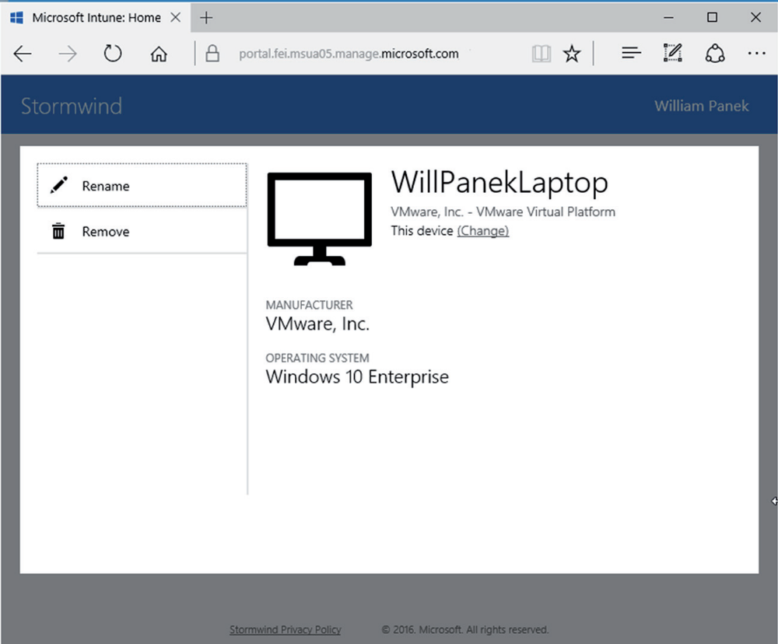

Apple iOS Administrators need to import an Apple Push Notification service certificate
from Apple so that you can manage iOS devices. Administrators need to open the Microsoft
Intune administration portal and go to Administration ➢ Mobile Device Management ➢ iOS
and Mac OS X ➢ Download the APNs Certificate Requests (see Figure 6.10). Administrators
then must save the certificate signing request (.csr) file locally. The .csr file is used to request
a trust relationship certificate from the Apple Push Certificates Portal. The administrator then
needs to click the Upload The APNs Certificate.

Windows Phone Administrators must set up some management requirements before
Windows Phones will work with your Intune network. DNS administrators need to create
CNAME records in order for users to connect to the Intune network resources. Windows
Phones also require a certifi cate to establish encrypted communications between the client
device and the Intune cloud-based system.
Windows Devices Windows devices are connected basically the same way as Windows
Phones. The DNS administrator has to create a CNAME record, and then applications can
be sideloaded into the Windows computer. Users can also connect to Intune by using the
Intune Management Portal.

